Experiment 9
1. Aim
To understand and implement Business Intelligence security concepts including authentication, authorization, role-based access control, and data protection mechanisms using Microsoft Power BI.

2. Objectives
- Understand authentication and authorization in Business Intelligence systems.
- Identify organizational users and their information requirements.
- Design role-based access and permission matrices.

3. Tools / Software Required
1. Microsoft Power BI Desktop
2. Microsoft Power BI Service
3. Global Superstore Dataset.xlsx
4. Microsoft Excel

4. Theory
Security is a critical component of Business Intelligence systems. BI platforms often contain sensitive organizational information that must be protected from unauthorized access. Authentication verifies the identity of a user, while authorization determines the resources and actions that the user is permitted to access. Access control mechanisms ensure that users can only view data relevant to their responsibilities. Power BI supports security through workspace permissions, sharing controls, Row-Level Security (RLS), and role-based access control.

Business Scenario
Global Superstore has multiple departments including Sales, Finance, and Regional Management. Each department requires access only to information relevant to its responsibilities. Students will act as BI Security Administrators and design a secure access strategy for organizational reports and dashboards.

5. Procedure

Part A: User and Role Identification

Step 1: Create the Role and Permission Matrix
- Open your existing Global Superstore .pbix file.
- Go to Home → Enter Data.
- Enter the following table:
User Role | Reports Accessible | Information Required
CEO | Executive Dashboard | Overall Sales, Profit and Business Performance
Sales Manager | Sales Dashboard | Sales, Orders and Customer Performance
Finance Manager | Finance Dashboard | Revenue, Profit and Profit Margin
Regional Manager | Regional Dashboard | Regional Sales and Profit
- Name the table Role_Matrix.
- Click Load.
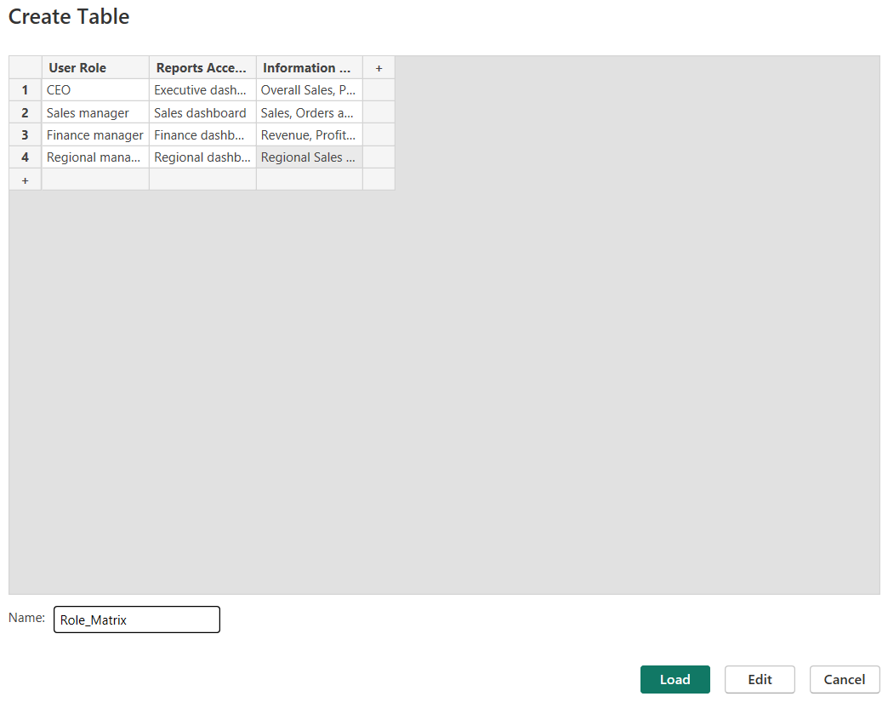

Part B: Authentication Analysis

Step 2: Create an Authentication Comparison Table
- Go to Home → Enter Data.
- Enter the following table:
Authentication Method | Description | Security Level
Username and Password | Users sign in using registered credentials. | Basic
Organizational Account | Users authenticate using their organization's Microsoft account. | High
Multi-Factor Authentication (MFA) | Users verify their identity using an additional authentication method. | Very High
- Name the table Authentication_Analysis.
- Click Load.
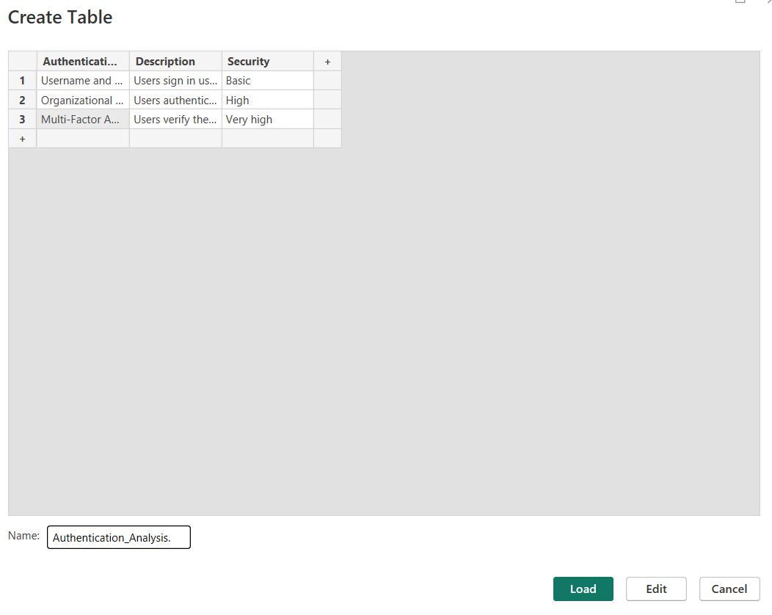

Part C: Authorization and Access Control Design

Step 4: Create the Access Control Matrix
- Select Home → Enter Data.
- Enter the following table:
User Role | View | Edit | Share | Admin
CEO | Yes | No | No | No
Sales Manager | Yes | Yes | No | No
Finance Manager | Yes | Yes | No | No
Regional Manager | Yes | No | No | No
BI Administrator | Yes | Yes | Yes | Yes
- Name the table Access_Control_Matrix.
- Click Load.
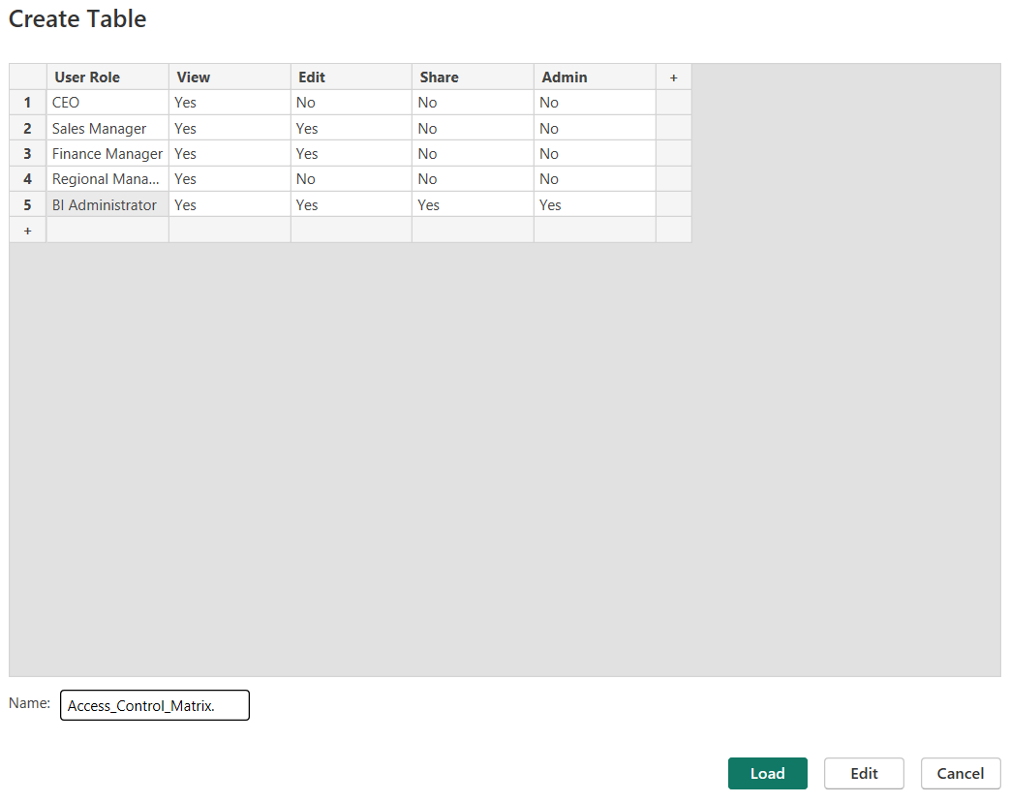
Part D: Row-Level Security (RLS) Planning
Step 6: Create a Region-Based Security Role
- Open your existing Global Superstore report.
- Go to the Modeling tab.
- Click Manage roles.
- Click New.
- Name the role Southern_Africa_Manager.
- Select your Orders table.
- In the table filter expression, enter:
- [Region] = "Southern Africa"
- Click Save.
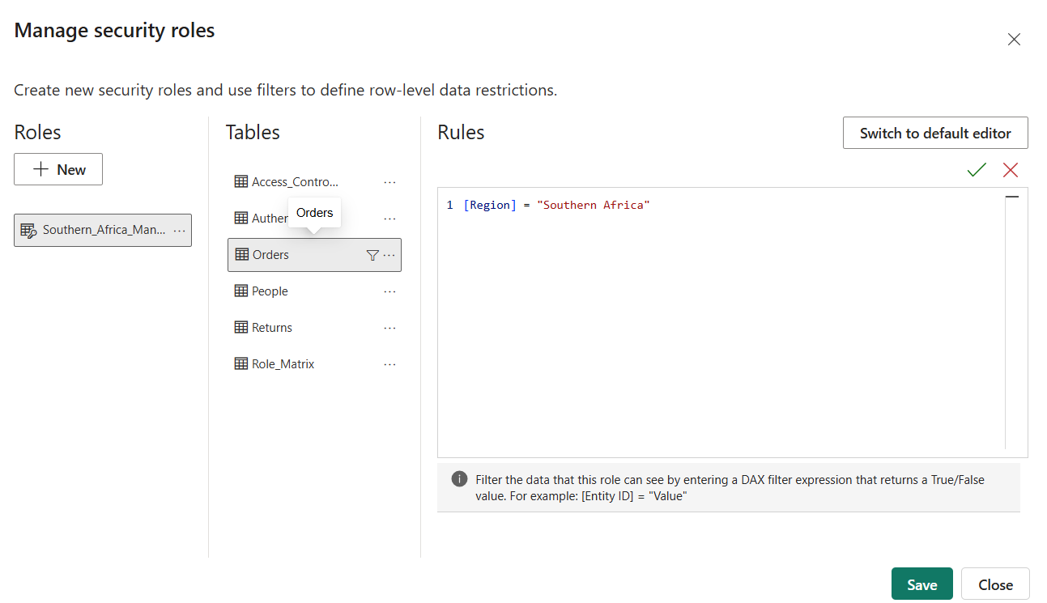

Step 7: Test Row-Level Security
- Go to Modeling → View as.
- Select the Southern_Africa_Manager role.
- Click OK.
- Open your Sales by Region chart.
- Verify that only Southern Africa data is displayed.
- To exit the test, select Stop viewing in the top ribbon.
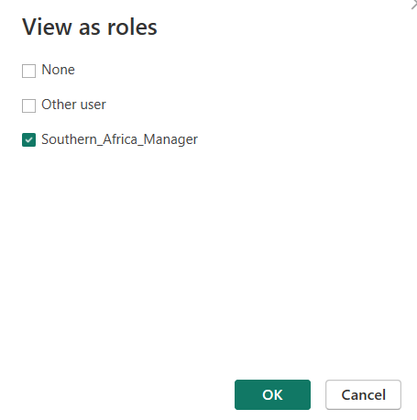
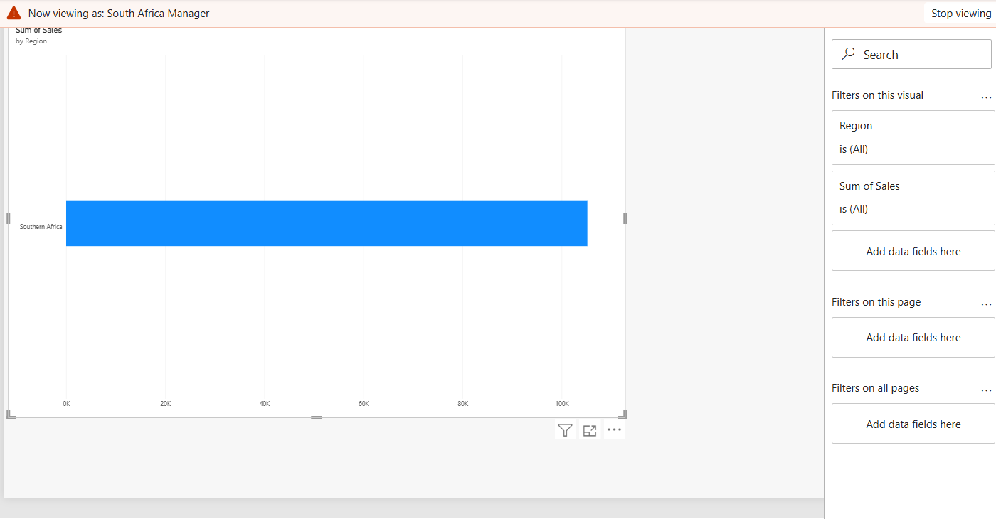

Step 8: Create another RLS role
Repeat the same process:
- Modeling → Manage roles → New.
- Enter role name Central_Asia_Manager.
- Select the Orders table.
- Enter: [Region] = "Central Asia"
- Click Save.
- Test it using Modeling → View as.
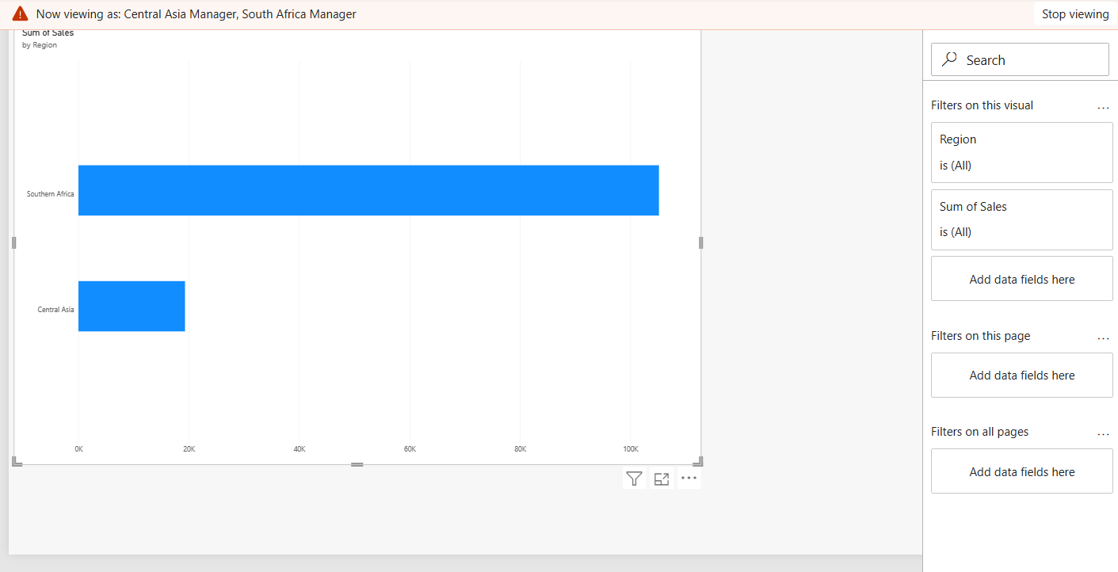

Step 9: Create a Security Risk Assessment Table
- Select Home → Enter Data.
- Enter:
Security Risk | Description | Impact
Unauthorized Access | Unapproved users accessing reports | Data leakage
Excessive Permissions | Users receiving unnecessary privileges | Data modification
Data Leakage | Sensitive business information being exposed | Confidentiality loss
Weak Authentication | Use of weak or stolen passwords | Account compromise
Incorrect RLS Configuration | Users viewing data outside their assigned region | Unauthorized data access
- Name the table Security_Risk_Assessment.
- Click Load.
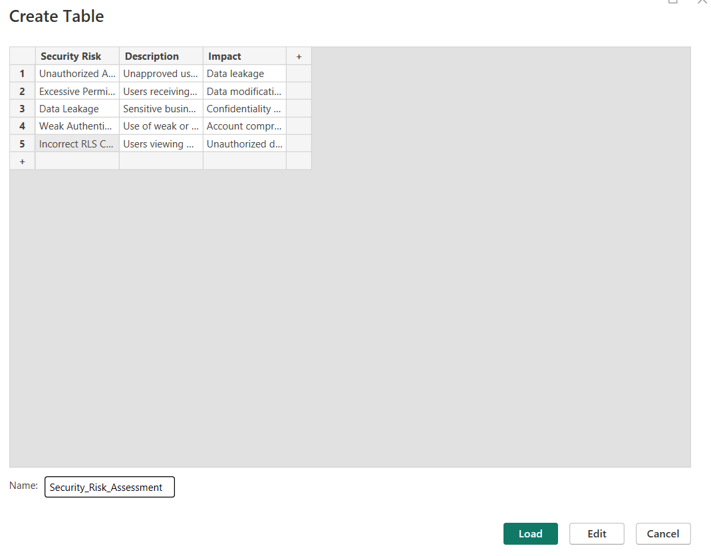

Step 10: Create Security Recommendations Sheet
- Select Home → Enter Data.
- Enter:
Security Risk |  | Recommended Security Control
Unauthorized Access | Restrict access to approved users
Excessive Permissions | Apply least-privilege access
Data Leakage | Use secure sharing and data protection policies
Weak Authentication | Enable strong passwords and MFA
Incorrect RLS Configuration | Test and verify RLS roles regularly
- Name the table Security_Recommendations.
- Click Load.
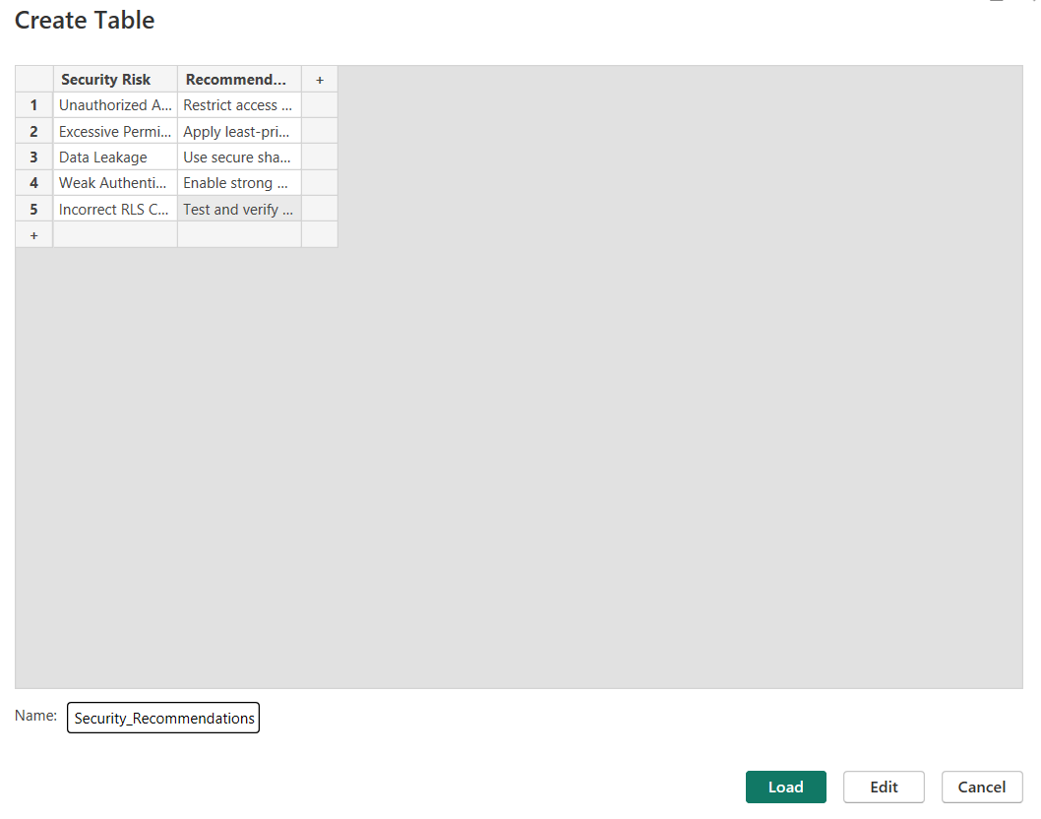

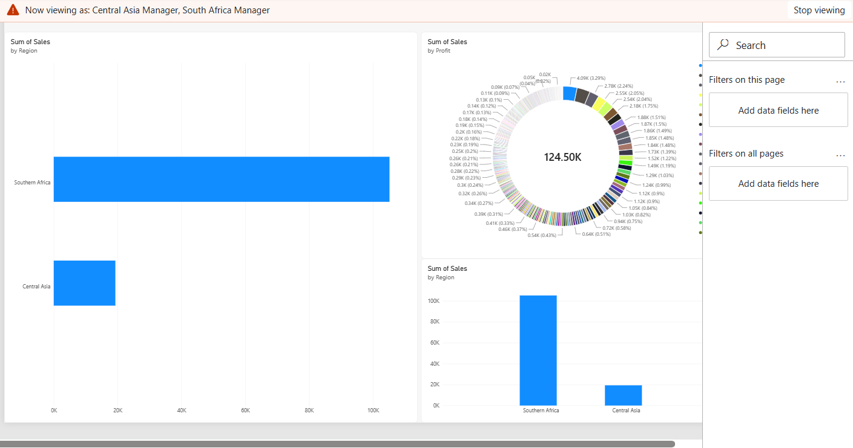

Result
A secure BI access strategy was successfully designed using authentication, authorization, and access control principles. User roles, permissions, and security measures were defined to protect organizational data and ensure controlled access.
Learning Outcomes
• Explain authentication, authorization, and access control concepts in BI systems. (CO1-BT2)
• Identify security requirements for different organizational roles. (CO1-BT2)
• Analyze access control mechanisms and permission structures. (CO4-BT4)
• Evaluate security risks associated with BI deployments. (CO4-BT4)
• Design secure access strategies for BI environments. (CO4-BT4)

